**Assignment - 1 - Building a weather app**

The app should have a responsive user interface that works well on both desktop and mobile devices.

Users should be able to search for a city by name and see the current temperature, weather conditions, and wind speed for that location.

Users should be able to switch between Celsius and Fahrenheit units of measurement.

The app should use a public weather API (such as OpenWeatherMap) to retrieve the current weather data.

The app should display appropriate error messages if the API returns an error or the user's search query does not match any known locations.

The app should include a "recent searches" feature that displays a list of the last five cities that the user has searched for.

The candidate should use appropriate error handling and validation to ensure that the application is robust and user-friendly.

Navigation and header bar should be same across page.

Some chart should render to show past weather data.

**Assignment - 2 – State wise summary**

UI should render some graph for state(10-15 state) on similar line attached below(not exactly) on the back of response json.

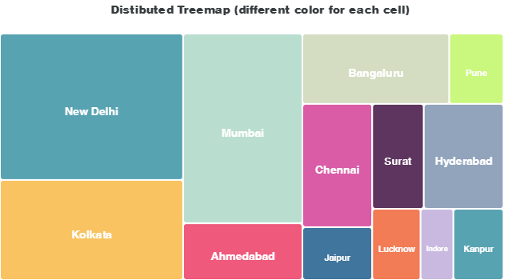

Navigation bar and header bar should be same across page.

On mouse over tool-tip should some basis info like temp, population etc.

Colour should varies in b/w RED and blue, on basis of one temp.

High temperature state should show red colour and lowest temp state should bluish colour.

If someone click over state then some chart should display like below with cities(4-5 city) info(any info).

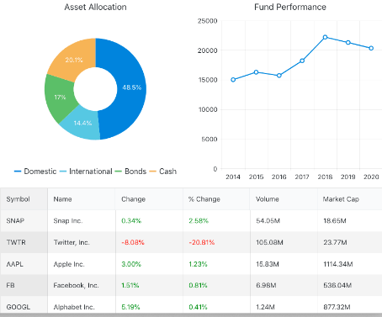

Note - You can use any json response or temp data base to populate these charts.